2 Talbot Method for Strain Analysis
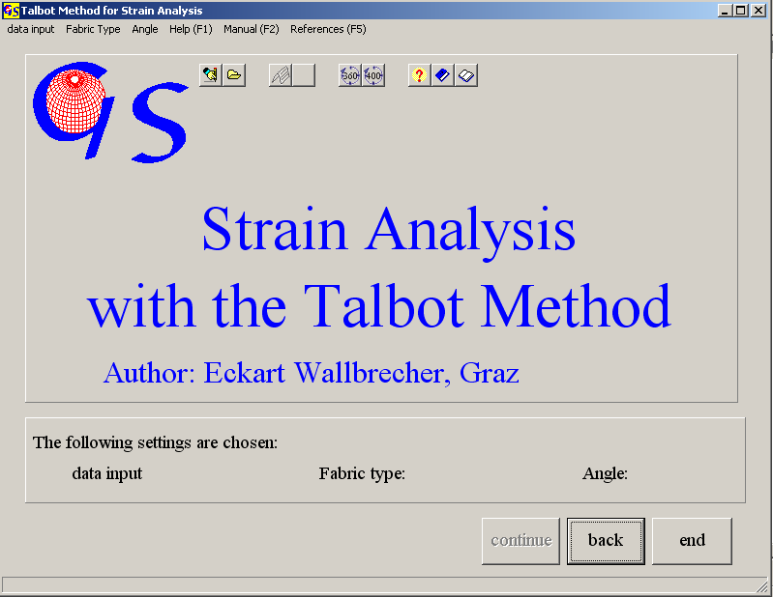
Fig. 1

This program carries out a strain analysis and the plot of a Flinn diagram from orientation data of elongated (boudinaged) and shortened (folded) markers,i.e. intersection of veins with outcrop surfaces (Talbot, 1970).
Manual data input is done with direction of dip and angle of dip. For shortened linears (Compression) the input of azimuth is negative (Fig. 2). The input from data files is the same as in all other programs.
Fig 3 shows the graphic for the data plot. Red dots are shortened linears, the blue ones are stretched. In case the diagramm shows strong concentration of points in one cluster some of the points should be erased by pressing "remove clusters" and then click on the data which should be erased. Best results are obtained, when the spread of data is even.
With the button "Orientientation of the strain ellipsoid" the cone that separates the compressional area from the tensional (light blue) is calculated. From this cone we receive the directions of the principal stresses (Fig. 4).
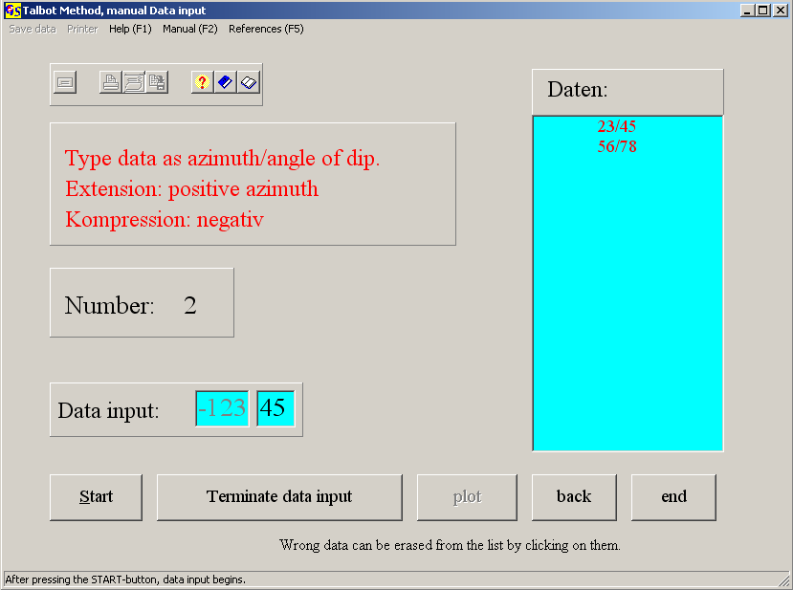
Fig. 2

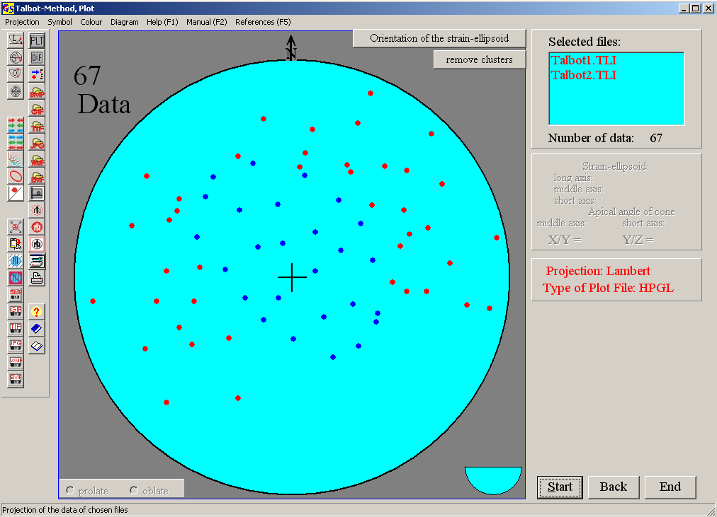
Fig. 3

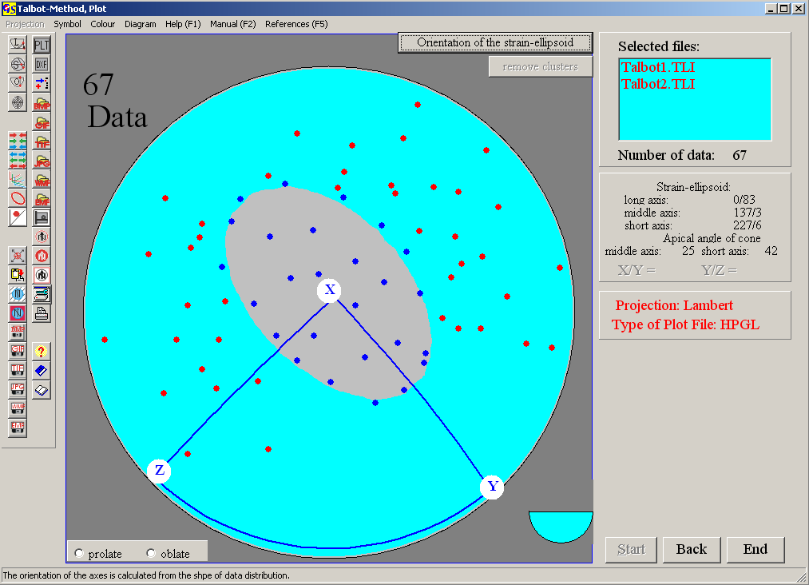
Fig. 4

These directions and the lengths of the long and short axes of the cone are listed in the table on the right side.
Fig. 5 shows the resulting Flinn-diagram. In order to produce this diagram, you have to click either on the prolate or oblate button. The ratios a = x/y and b = y/z are shown in the table on the right side.

The options of the menu "Diagram" are explained in program 3.

